 |  | Order Form
Name: |  | return FORM: By Friday August 21, 2020
Contact Number:  Address: |  | Pick up Date: Tuesday september 1, 2020  HOURS 10am to 3pm (at your nominated Routleys shop – refer to list)
Quantity | item / DESCRIPTION |  | cost | Total $
 | Meat Pie Round (4 pack) |  | 12.00
 | Beef & Onion Pie (4 pack) |  | 13.00
 | Pasties – Meat & Vegetable (4 pack) |  | 13.00
 | Pasties – Vegetarian (4 pack) |  | 14.00
 | Shepherd’s Pie (4 pack) |  | 13.00
 | PARTY SIZE – 6 PACKS
 | Party Pie 6 pack |  | 7.00
 | Party Pasties 6 pack |  | 7.00
 | Party Sausage Rolls 6 pack |  | 7.00
 | Party Quiche Lorraine 6 pack |  | 8.00
 | Large Sausage Rolls - 6 pack |  | 11.50
 | FAMILY SIZE
 | Family Meat Pie |  | 10.50
 | Family Pastie |  | 10.50
 | Family Shepherd Pie |  | 11.50
 | Family Apple Tart |  | 10.50
 | Family Apricot Tart |  | 10.50
 | ASSORTED CAKE LINES
 | Lamingtons (4 pack) |  | 7.50
 | Apple Slice (4 pack) |  | 9.00
 | Iced Donuts (4 pack) |  | 6.50
 | Vanilla Slices (4 pack) |  | 9.00
TOTAL Packs |  |  | Total $

Please write quantity totals clearly, eg: if ordering 4 Family Meat Pies write 4 not 1111
Your order is packed from this form. Thank you!

Selection of items to order

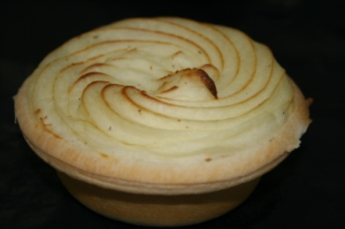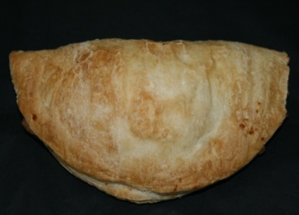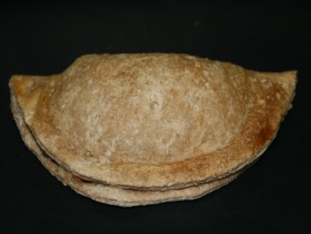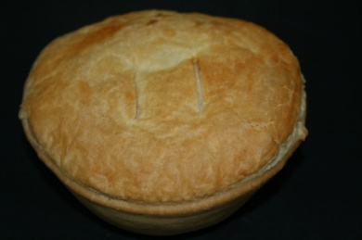
Shepherd’s Pie Meat & Veg Pastie Vege Pastie Beef & onion Pie

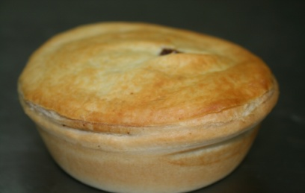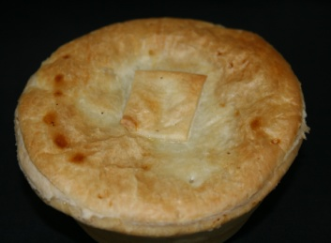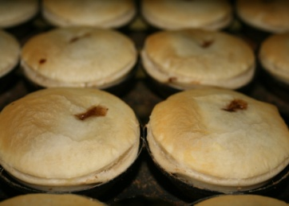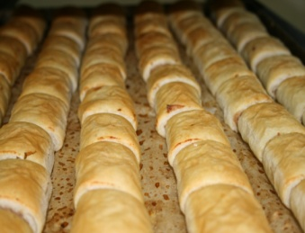
Meat Pie Beef, Tom & Onion Pie Party Pies Party Sausage Roll

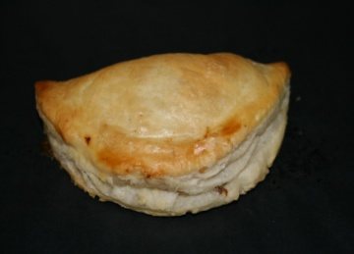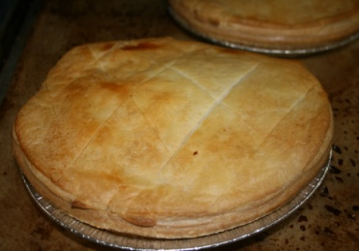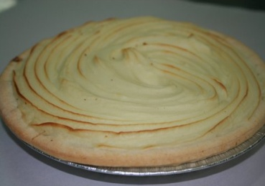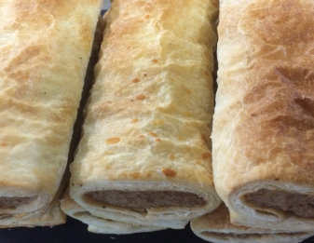
Party Pastie Family Pastie Family Shepherd’s Pie Sausage Rolls

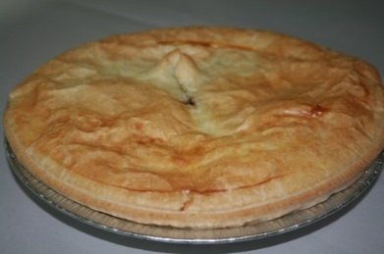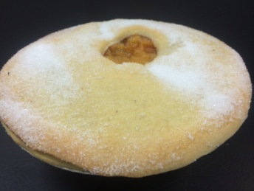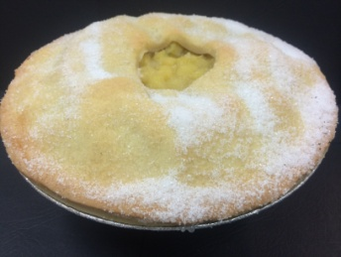
Party Quiche Family Meat Pie Apricot Tart Apple Tart

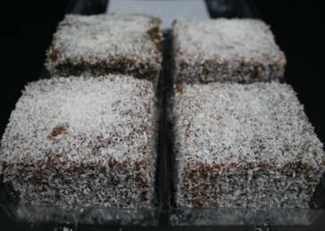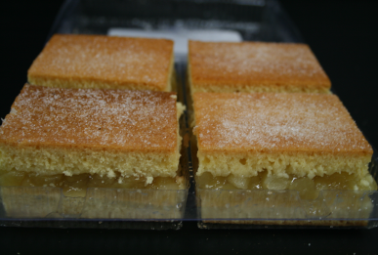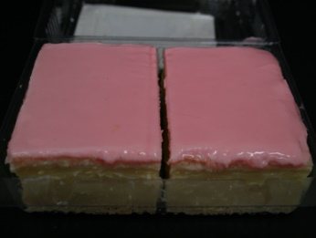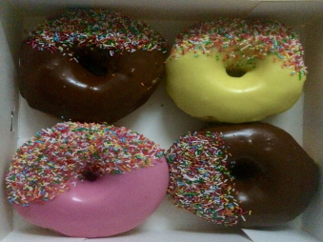
Lamingtons Apple Slice Vanilla Slice Donuts
Thank you for your support

