|  |  |  |  |  |
| --- | --- | --- | --- | --- |
| PIE DRIVE | | Routleys logo 2 | | |
| **Name:** | | **return FORM:** Friday 23 July 2021 | | |
| **Contact Number:** | | **PICK UP DATE:** Thursday 29 July 2021  10AM to 12noon (The Annex, 35 Mount Pleasant Road, Belmont) | | |
| Quantity | item / DESCRIPTION | | cost | Total $ |
|  | Meat Pie Round (4 pack) | | **12.00** |  |
|  | Beef & Onion Pie (4 pack) | | **13.00** |  |
|  | Pasties – Meat & Vegetable (4 pack) | | **13.00** |  |
|  | Pasties – Vegetarian (4 pack) | | **14.00** |  |
|  | Shepherd’s Pie (4 pack) | | **13.00** |  |
|  | **Party Size** | |  |  |
|  | Party Pie (6 pack) | | **7.00** |  |
|  | Party Pasties (6 pack) | | **7.00** |  |
|  | Party Sausage Rolls (6 pack) | | **7.00** |  |
|  | Party Quiche Lorraine (6 pack) | | **8.00** |  |
|  | Large Sausage Rolls (4 pack) | | **11.50** |  |
|  | **Family Size** | |  |  |
|  | Family Meat Pie | | **10.50** |  |
|  | Family Pastie | | **10.50** |  |
|  | Family Shepherd Pie | | **11.50** |  |
|  | Family Apple Tart | | **10.50** |  |
|  | Family Apricot Tart | | **10.50** |  |
|  | **Assorted Cakes** | |  |  |
|  | Lamingtons (4 pack) | | **7.50** |  |
|  | Apple Slice (4 pack) | | **9.00** |  |
|  | Iced Donuts (4 pack) | | **6.50** |  |
|  | Vanilla Slices (4 pack) White or Pink Iced | | **9.00** |  |
|  | **Gluten Free Party Pie (6 Pack)** | | **12.00** |  |
|  | **Low Gluten Lamington (4 Pack)** | | **9.00** |  |
|  | TOTAL Packs | | **Total $** |  |

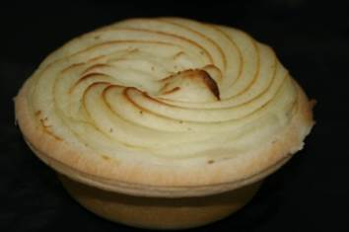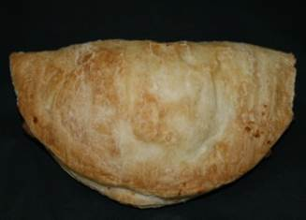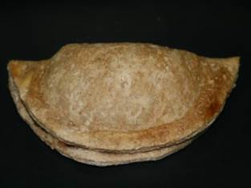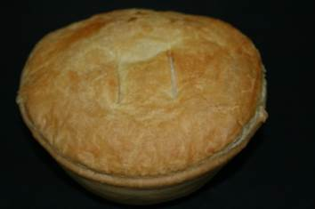

Shepherd’s Pie Meat & Veg Pastie Vege Pastie Beef & Onion Pie

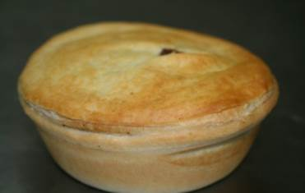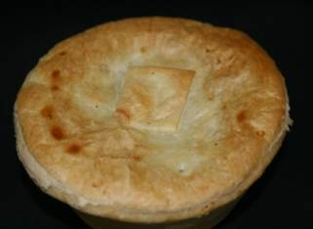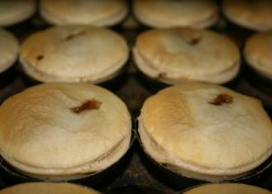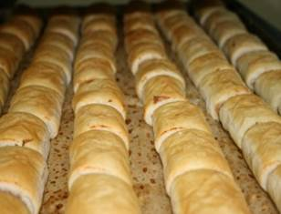

Meat Pie Beef & Onion Pie Party Pies Party Sausage Roll

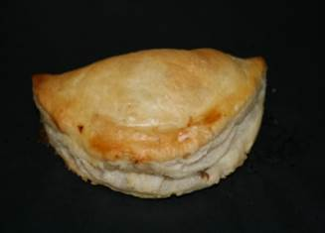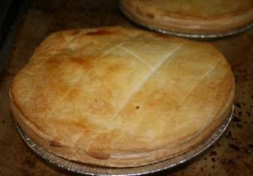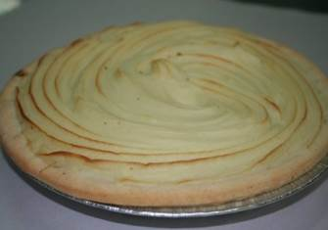

Party Pastie Family Pastie Family Shepherd’s Sausage Rolls  
 Pie

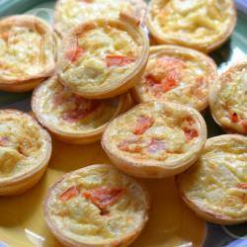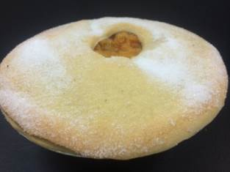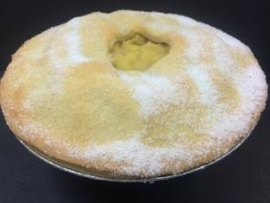

Party Quiche Family Meat Pie Apricot Tart Apple Tart

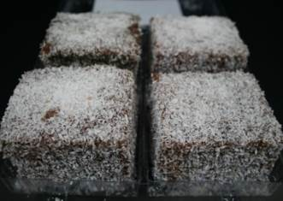

Lamingtons Apple Slice Vanilla Slice Donuts

GF Party Pies Low Gluten Lamingtons